**Shell Scripting Documents**

* **Firstly we can check all the shells available on our system.**

**Command -> cat /etc/shells**

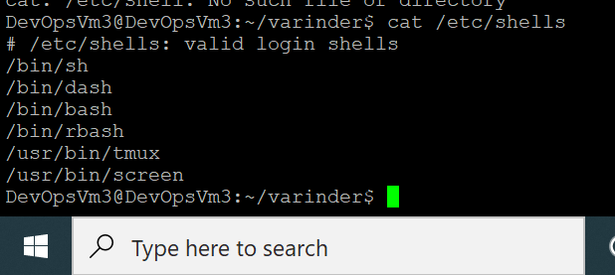

* **Too check the path of the bash**

**Command -> which bash**

* **To write a script start with**

**#! /bin/bash**

**Continue to coding.**

* **Syntax for conditional statement**

1. **If statement**

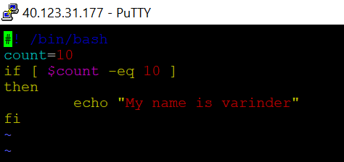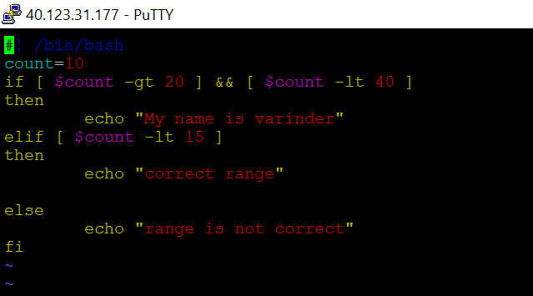

* **Syntax for loop statements**

1. **While loop**

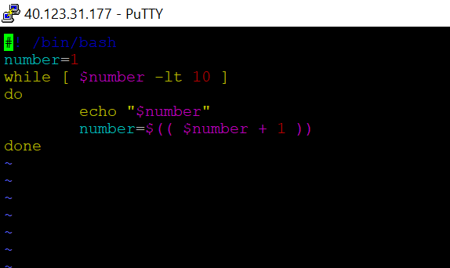

1. **For loop**

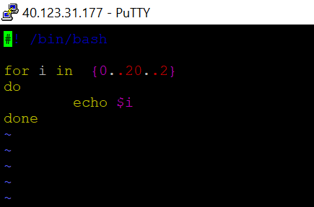

* **Syntax for input and output**

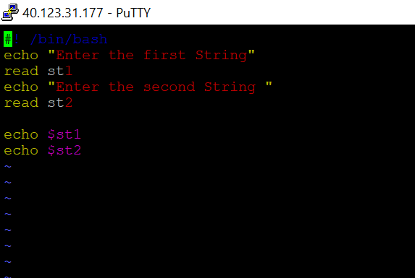

* **Basically we can use the script to reduce that work which we can do again and again.**

**If we want to create a directory and make a file into it then we can write many lines if we can write these many lines into the script then if in future we want to create a directory and file into it then we cannot write many line we can just execute the script.**

* **In this I am create a file file.txt with the help of the script**

